While reviewing the profile completion section, the "Which social causes are important to you?" question, there’s a usability issue. Currently, users can select "None" or "Other" alongside other options (e.g., Climate Change, Social Justice, etc.), which might lead to inconsistent or contradictory responses.

It might be better to make the selection exclusive, so if a user chooses "None" or "Other," the other options are automatically deselected (and vice versa). This would ensure a smoother user experience.

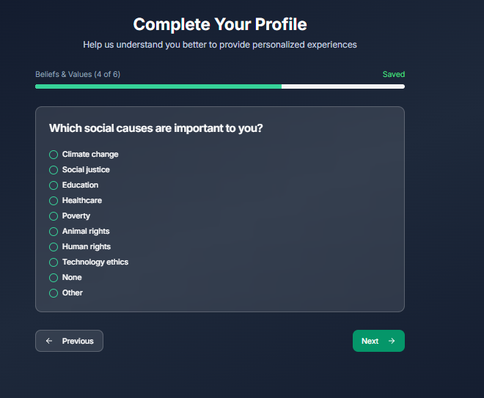

There were several questions like that. Another screenshot for reference:

